**Micro-Mobility Service Coverage Dashboard User Guide**

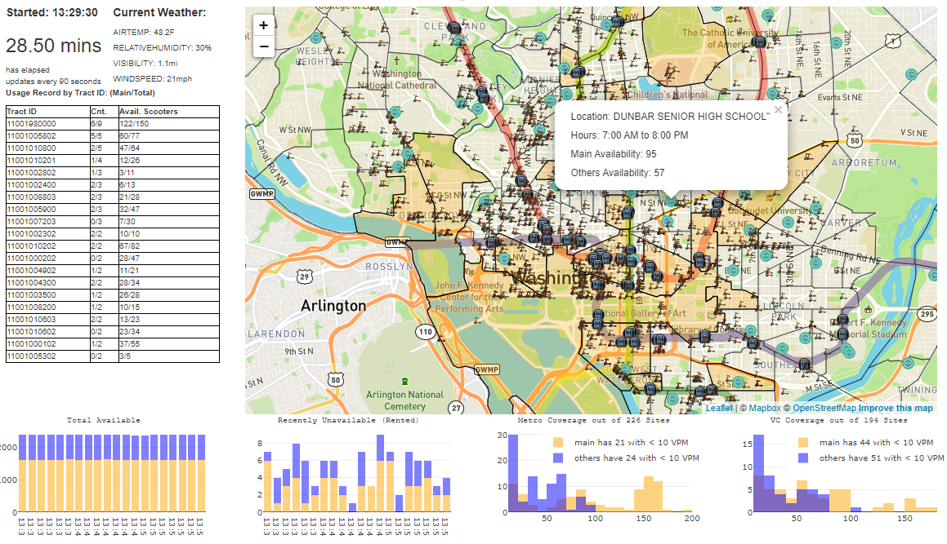

**Overview:**

This dashboard was created for the purposes of understanding micro-mobility vehicles usage. All data utilized for the dashboard are real-time and are publicly available.

**Notes:**

* Usage is assumed when a vehicle becomes no longer available, according to the data from the API. There is a chance that vehicles are taken off for maintenance purposes.
* Due to the nature of the online dashboard, no data is stored offline. Therefore all data is cleared if the browser is refreshed.

**Dashboard Sections**

1. Time and Weather
   1. The data is refreshed every 60 seconds. There should not be data leakage, considering that the average trip duration per use is typically ~10 mins.
   2. The weather data is obtained from a public API and refreshed in lock-step with the rest of the dashboard.
2. Usage Record
   1. The distribution of the vehicles is divided into locality known as Census Tract. For the purposes of analysis, each vehicle is assigned (calculated) to its designated Tract ID based on the provided latitude and longitude.
   2. The table tracks the top 20 most popular Census Tracts which transactions occur, in aggregate of all micro-mobility service operators. This table can be helpful to “recommend” reallocation of vehicles if a there is a lack of available vehicles. The idea is to monitor the table to ensure there is adequate availability where there is a high demand.
   3. Count (Cnt) and Available Scooters (Avail. Scooters) represent the numbers of uses within each Census Tract and the number of vehicles currently available, respectively. The figures are represented as “main/total”, where main is a (unnamed) selected operator. Other operators are considered as “others” in other parts of the dashboard.
3. Total Available
   1. The Total Available bar chart tracks the total number of vehicles currently available between the “main” and the “competitors” (others).
4. Recently Unavailable (Rented)
   1. Usage is assumed when the vehicle is no longer available, according to the data from the API.
   2. The Recently Unavailable bar chart tracks the usage activity in the last 20 mins, between the “main” and the “competitors” (others).
5. Metro Coverage (out of 226 Sites)
   1. VPM (vehicles per mile) is defined as the number of vehicles within a half-mile radius from a site.
   2. This histogram represents the distribution of the vehicles across all metro station entrances (226 at the time of writing).
   3. For example, taller bars on the left-hand side means that majority of the stations have less than 100 VPM, suggesting that these sights might be underserved. On the other hand, taller bars on the right-hand side means that majority of the stations have more than 150 VPM, suggesting that these sights might be overcrowded. This can be helpful to “recommend” redistribution actions based on the policy and procedures.
6. VC Coverage (out of 194 Sites)
   1. VPM (vehicles per mile) is defined as the number of vehicles within a half-mile radius from a site.
   2. To encourage people to vote, several companies have committed to promotion that aims to help improve voter turnout. As part of that commitment, there should be adequate VPM at each of the voting centers. At the time of writing, there are 194 registered voting centers, of which majority of them are well covered.
   3. This can be helpful in monitoring how the public utilize micro-mobility services and if it can improve voter turnout.
7. Interactive Map
   1. Users can click on the below to get more real-time information:
      1. Top Census Tract – see the total number of usage and availability
      2. Voting Center – see the current availability, as defined by VPM (vehicles per mile)
      3. Metro Station – see the current availability, as defined by VPM (vehicles per mile)

Data Sources:

* Spin Availability API
* Bird Availability API
* Lime Availability API
* Lyft Availability API
* Razor Availability API
* Skip Availability API
* DC Open Data –
  + Census Tract
  + Subway Station
  + Voting Centers
* Weather API